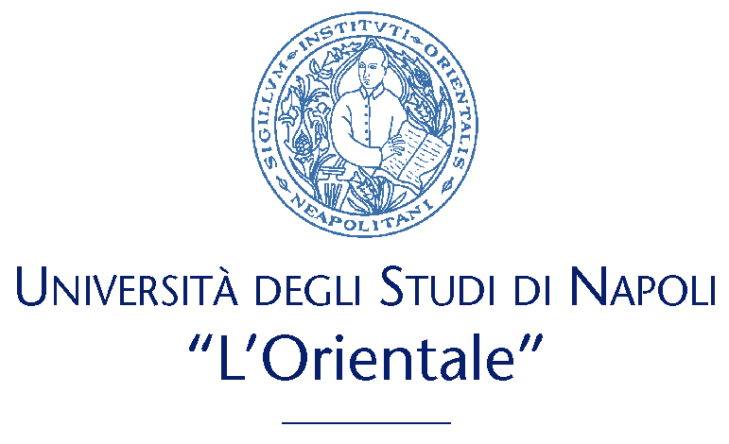
Ufficio Progetti Europei e Internazionali

INFORMATION SHEET
2018/2019

INSTITUTION | UNIVERSITA’ DEGLI STUDI DI NAPOLI “L’ORIENTALE”  via nuova marina 59  80134 – Napoli  Italia
ERASMUS CODE | I NAPOLI 02
ERASMUS INSTITUTIONAL COORDINATOR  (address, e-mail, telephone) | Prof. Sergio Corrado  Dipartimento di Studi Letterari, Linguistici e Comparati  Palazzo Santa Maria Porta Coeli,  Via Duomo, 219  80138 Napoli  Italia  scorrado@unior.it  TEL. +39-081-6909315-375-079
Institution website (course descriptions, academic calendar etc.) | http://www.unior.it
Website for incoming Erasmus students | http://www.unior.it/ateneo/1/1/ateneo.html  www.erasmuspoint.net (housing & visa)
Contact Information | UFFICIO PROGETTI EUROPEI E INTERNAZIONALI  Università degli Studi di Napoli “L’Orientale”  Via Nuova Marina n° 59  80134 – Napoli  Head-Office  Dott.ssa Benedetta Bovenzi  bbovenzi@unior.it  Erasmus+ Incoming Students & bilateral agreements  Dott.ssa Rossella Della Corte: erasmus@unior.it  Erasmus+ Traineeship  Dott.ssa Giuliana Casaburi: erasmus@unior.it  Sig.ra claudia lubreto : cflubreto@unior.it  Erasmus+ outgoing  Sig.ra maria ierardi mierardi@unior.it  non-eu countries  Dott.ssa Giusy Di Rosa: uffpei@unior.it  Dott.ssa Noemi Corbelli: uffpei@unior.it
Nominations | Nomination must be sent to the following e-mail:  Eu-countries: erasmus@unior.it  non-eu countries: uffpei@unior.it  By:  30th June for 1st Semester and full year  30th November for the 2nd semester  Please note: deadlines are only for eu-countries.
Application Procedure | After the nomination, Students will receive an e-mail with the application procedure instructions and the documents they need to fill out and send back by e-mail:  - The Application Form must be signed and sent by email to erasmus@unior.it PDF format.  - Learning Agreement (duly completed, signed by the coordinator at home University, by the student and officially stamped) PDF format.  - only for non-eu countries: grant agreement duly signed and filled out with the information required. please note: the bank account holder has to be the student himself.  each document must be duly signed and stamped by the sending institution in order to be accepted.
course catalogue (triennale –ba- and magistrale –ma-) | http://www.unior.it/ateneo/7849/1/offerta-didattica.html  TRIENNALE (BA)  Asia & Africa department  http://unior.it/ateneo/15730/1&IdAnno=90&IdCorsoLaurea=92/insegnamenti.html  http://unior.it/ateneo/15722/1&IdAnno=90&IdCorsoLaurea=116/insegnamenti.html  Human and Social sciences department  http://unior.it/ateneo/15740/1&IdAnno=90&IdCorsoLaurea=150/insegnamenti.html  Literary, linguistic and comparative studies department  http://unior.it/ateneo/15750/1&IdAnno=90&IdCorsoLaurea=160/insegnamenti.html  http://unior.it/ateneo/15758/1&IdAnno=90&IdCorsoLaurea=93/insegnamenti.html  http://unior.it/ateneo/15766/1&IdAnno=90&IdCorsoLaurea=94/insegnamenti.html  MAGISTRALE (MA)  Asia & Africa department  http://www.unior.it/ateneo/15780/1&IdAnno=90&IdCorsoLaurea=90/insegnamenti.html  http://unior.it/ateneo/15792/1&IdAnno=90&IdCorsoLaurea=110/insegnamenti.html  http://unior.it/ateneo/15802/1&IdAnno=90&IdCorsoLaurea=144/insegnamenti.html  Human and Social sciences department  http://unior.it/ateneo/15814/1&IdAnno=90&IdCorsoLaurea=111/insegnamenti.html  http://www.unior.it/ateneo/15827/1&IdAnno=90&IdCorsoLaurea=139/insegnamenti.html  http://www.unior.it/ateneo/15838/1&IdAnno=90&IdCorsoLaurea=154/insegnamenti.html  Literary, linguistic and comparative studies department  http://unior.it/ateneo/15848/1&IdAnno=90&IdCorsoLaurea=106/insegnamenti.html  http://unior.it/ateneo/15861/1&IdAnno=90&IdCorsoLaurea=117/insegnamenti.html  http://www.unior.it/ateneo/15874/1&IdAnno=90&IdCorsoLaurea=162/insegnamenti.html  http://unior.it/ateneo/15885/1&IdAnno=90&IdCorsoLaurea=161/insegnamenti.html  Phd Courses  Asia & Africa department  http://www.unior.it/ateneo/10747/1/dottorati-di-ricerca.html  Human and Social sciences department  http://www.unior.it/ateneo/10713/1/dottorati-di-ricerca.html  Literary, linguistic and comparative studies department  http://www.unior.it/ateneo/10760/1/dottorato-di-ricerca-in-studi-letterari-linguistici-e-comparati.html  The courses for the coming year have usually not yet been listed at the time you draft your Learning Agreement, but you can use the list of courses from the previous year to fill it out (for example, take the courses from the academic year 2017/18 as your guide when planning for Winter 2018/19). It is of course possible to adjust the Learning Agreement/Study Programme after your arrival in Naples.  The course catalogue is updated at the beginning of each academic year. Erasmus students have access to the whole academic offer, they can attend both bachelor and master courses (triennale/magistrale). Please be aware that most course units are held in Italian.For exams taught in English please see the annex to this information sheet.  Please note: Language courses at l’Orientale have a duration of a whole academic year. They consist of a part held by a professor or a lecturer (generally just one semester) integrated by classes held by a native speaker language assistant (both semesters).  However, Erasmus students are allowed to attend these courses even if they stay only for a semester.
Academic Calendar | the academic year is divided in two semesters, first and second semester, each semester lasting 5 months.  Courses:  http://unior.it/ateneo/7974/1/orario-delle-lezioni.html  Exams:  http://unior.it/ateneo/7855/1/appelli-degli-esami.html  please note: the academic calendar is displayed with provisions for possible amendments. it is usually updated at the beginning of the academic year but the length of the semester is always 5 months (including the examination sessions).
  Semesters | From | to
  Full academic year | 01 October | 01 june (End of the classes)
  First semester | 01 October | 12 January (end of fall semester)
  Second semester | 1st March | 01 June
   | From | To
  Winter Session | 12 January | 27 February
  Summer Session | June | July
  Autumn Session | 01 September | 10 October
Free Intensive Italian course | CLAOR - Centro Linguistico di Ateneo Università L’Orientale  Palazzo del Mediterraneo  Via Nuova Marina n° 59 80134 – V Piano  Tel. +39-081-6909045/044  Fax: + 39-081-6909255  e-mail: claor@unior.it  A free intensive italian language course is offered to all incoming students. this course (40h course) provides the students with 6 ects. Attendance is compulsory (6h of absence maximum)  Students who want to attend this course need to indicate it on their learning agreement in order to be added on the claor list.  for any issue, Please contact: erasmus@unior.it.  Non-eu: uffpei@unior.it
Accommodation & visa | Erasmuspoint Naples  C.so Umberto 132 – Napoli  Phone/Fax: +39/081/265622  e-mail: erasmuspoint@libero.it  website: www.erasmuspoint.net  About Erasmus Point  Eramus Point Naples provides free assistance for all international students, helping them with everything they might need during their stay in Naples: accomodation, Italian bank account, Italian SIM card, fiscal code, etc.
Adisurc (food service) | Adisurc  Via alcide de gasperi 45,  80134 Napoli  Adisurc is a regional organism which manages founds and facilitations for students. Adisurc office will provide the students with a card which gives discounts in our partner restaurants.
Insurance | L’Orientale will provide all incoming students with an accident insurance policy which covers them in each University building. In order to take out this policy students will have to give us a copy of a valid ID card.
Transcript of records | The Transcript of Record (ToR) will be uploaded on the student’s personal page after the administrative office has received all grades of the student’s exams. This will depends on how long the departments take to mark the exams. It may take until the beginning of the next semester. After that, students will be able to download it.

